Creative Clubs
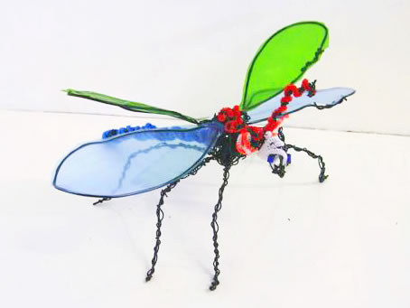The project employs qualified artists to lead 2 hour workshops on Saturday mornings for children between the age of 8-11 together with 2 hour weekly evening workshops for children between 11 and 15 years old. The project provides a creative outlet for young people, enhancing their skills and introducing them to produce work in a community setting, thus inducing pride in their surroundings and responsibility for their environment. Apart from introduction to a wide variety of creative activities they have been involved in the creation of artwork which has been on public display.
The main aims of the project are to:-
Break down barriers between young people and adults
To foster community spirit and reduce anti-social behaviour
To encourage pride and care of the environment
To increase skills leading to increased self-esteem and aspirations
The children had the opportunity to try collage, graffiti art, model landscapes, street dance, wire sculpture, drama, re-cycled clothing and work in clay.

